1. Free Assets for Everyone

<https://www.gameart2d.com/freebies.html>

<https://gameartpartners.com/downloads/totally-free-goodies/>

<https://www.glitchthegame.com/>

<https://www.gamedevmarket.net/>

<https://opengameart.org/>

<https://spritedatabase.net/>

<https://www.supergameasset.com/>

https://pressstart.vip/tutorials

1. Game Loop

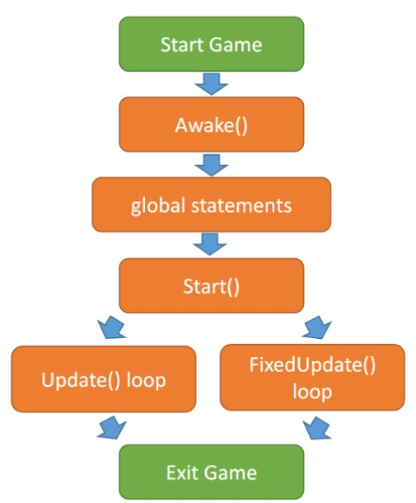

1. Script lifecycle

class Player : MonoBehaviour {

// Khai báo biến private, public, protected

// Constructor // Awake() {}

// Start() {}

// Update() {} // FixedUpdate() {}

}

<https://docs.unity3d.com/Manual/ExecutionOrder.html>

1. Các lớp cần lưu ý trong UnityEngine
   * GameObject
   * MonoBehaviour
   * Input
   * Transform
   * Vector3/Vector2

1. Simple Example

*Di chuyển, xoay nhân vật simple dùng Transform*

|  |
| --- |
| using System.Collections; using System.Collections.Generic; using UnityEngine;    public class Player : MonoBehaviour  {  // transform là 1 đối tượng thuộc lớp Transform  // spriteRenderer là 1 đối tượng thuộc lớp SpriteRenderer    public float moveSpeed = 5f; public Vector3 moveInput;  // Start is called before the first frame update void Start()  {    }    // Update is called once per frame void Update()  {  moveInput.x = Input.GetAxis("Horizontal"); moveInput.y = Input.GetAxis("Vertical");  transform.position += moveInput*moveSpeed *Time.deltaTime;    if(moveInput.x !=0)  {  if(moveInput.x >0)  {  transform.localScale = new Vector3(1, 1, 0);  } else {  transform.localScale = new Vector3(-1, 1, 0);  }  } |

}

}

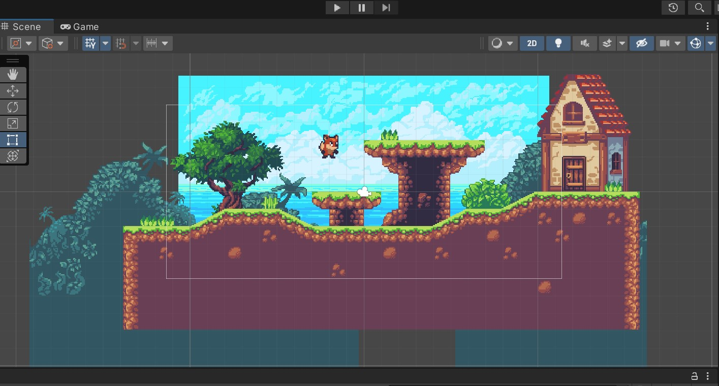

<https://docs.unity3d.com/Manual/class-Tilemap.html>

(Manual https://docs.unity3d.com/Manual/Unity2D.html)